C#.NET

Winforms

.NET 6.0

Nuget package manager: addons

Nlog

<https://nlog-project.org/>

ftp

<https://github.com/sparkeh9/CoreFTP>

Ini file handler

<https://www.nuget.org/packages/Microsoft.Extensions.Configuration.Ini/8.0.0-preview.4.23259.5#show-readme-container>

Mqtt

<https://github.com/dotnet/MQTTnet>

Sharedmemory

<https://github.com/justinstenning/SharedMemory>

SQLLite

Also consider

1. tcp nuget packages
2. look at esp32 nuget packages , might make it easier to communicate to esp32’s

NlogViewer

Sentinel

<http://ishegatron.github.io/Sentinel/>

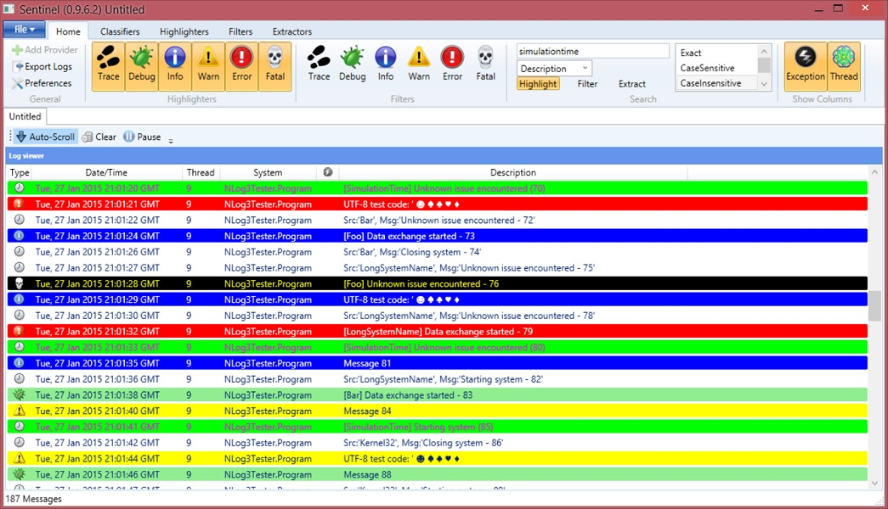

**OR**

<https://sourceforge.net/projects/styort-logviewer/>

install to C:\program files(manual)\nlogviewer/

